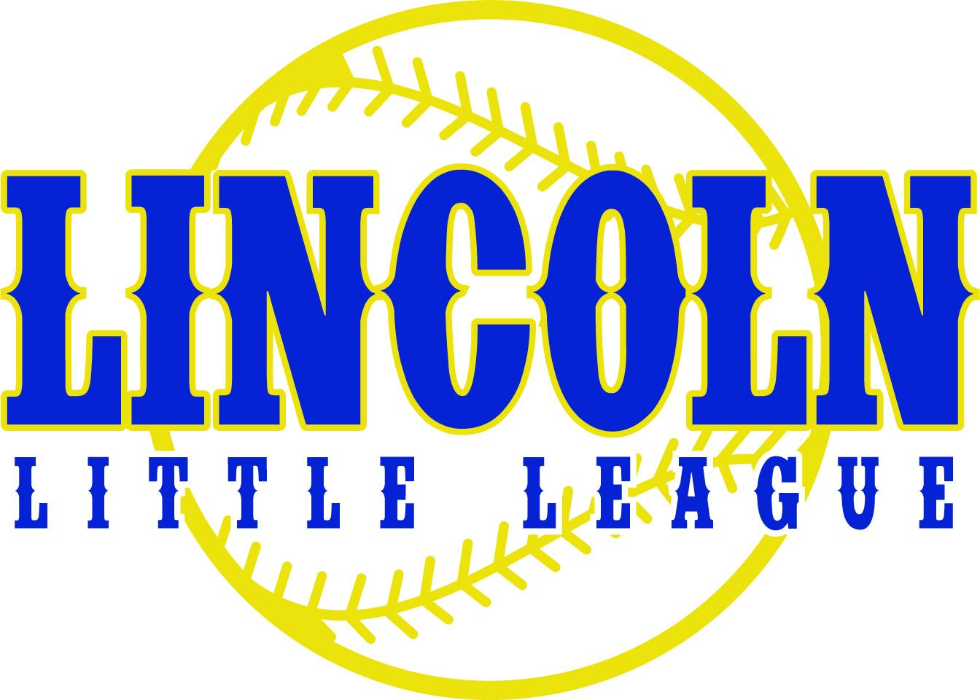

**2024 - 2025 Expectations of Conduct**

Lincoln Little League’s Code of Conduct is intended to establish a positive framework for all activities for LLL players and their families, both on and off the field. Our goal is to eliminate misconduct and promote positive behavior and sportsmanship. Our Code of Conduct will be enforced at all times and at all LLL events, including practices, games (home or away), team get togethers and community events.

All board members, parents, volunteers, and players are expected to exemplify our **Core Values**.

* **Respect**
  + Treat all participants, including players, coaches, officials, and fellow parents/volunteers, with respect and courtesy.
  + Discrimination, harassment, or bullying of any kind WILL NOT BE ALLOWED.
* **Teamwork**
  + Work together for the great benefit of all involved.
  + Follow all safety guidelines and league rules.
* **Positive Attitude**
  + Challenges will be met with a drive and attitude of perseverance
  + Players will be encouraged and supported through mistakes
* **Positive Role Model**
  + Refrain from using foul or offensive language at league events, games, and practices.
  + No Drugs or Alcohol Use: Do not use or be under the influence of drugs or alcohol at league events or when responsible for the well-being of players.
* **Commitment**
  + Do what you say and say what you do

As a parent/guardian of a child playing in LLL, I agree to be held to the following “Expectations of Conduct.”

* I will respect the League Officials, umpires, fans, coaches and players
* I will respect decisions made by League officials
* I will positively support teams in every way possible
* I will not interfere in any way with the playing of the game
* I will not confront, argue with or threaten any coach, umpire or League Official
* I will not criticize officials in any way or show displays of anger with an official's call
* I will treat competition as a game and keep winning in its proper place
* I will encourage my child to display good sportsmanship, fair play and display appropriate behavior at all times
* I will support the rules and regulations of LLL
* I will conduct myself appropriately at all Lincoln Little League games, practices and activities
* Alcohol, tobacco (in any form, including vaping) and illegal drugs are not allowed in or near any Little League field.
* I understand that umpires have the authority to have anyone removed from a practice or game for conduct that is not consistent with the expectations that have been described above. Umpires have the right to suspend play or forfeit a game, if necessary.

For the purpose of this policy, misconduct include, but is not limited to the following behaviors:

* Inappropriate or vulgar language
* Threats and attempts to intimidate
* Throwing articles in a deliberate or aggressive manner
* Approaching another individual in an intimidating/aggressive manner
* Attempts to goad or incite violence in others
* Vandalism to LLL buildings or other property
* Racial or Ethnic slurs
* Disrespect of any League Official, umpire, manager, coach, player or other parent
* Engaging in an activity the jeopardizes the safety of participants

I further understand that it is an expectation that my child will exhibit exemplary behavior both on and off the field of play and will emphasize good sportsmanship throughout the season. Some of those expectations are:

* Players will not throw or in any other way abuse equipment.
* Players will not use abusive, vulgar or profane language in any manner, especially when directed at other players, coaches or umpires.
* Players will not argue or protest extensively ball/strike, fair/foul or out/safe calls by the umpires.
* Players will remain in the dugout at all times unless given permission by the manager or coach to leave.
* No tobacco products of any kind, alcohol or drugs are permitted in the dugout or on the playing field during practice or games.

I understand that any misconduct will be subject to discipline from the LLL Disciplinary Committee. Disciplinary actions may vary, but will reasonably follow this guideline:

First Offense: Verbal warning and discussion of the infraction with offender and team manager.

Second Offense: Written warning and one game suspension

Third Offense: Expulsion for the league with no refund or registration fees.

All issues will be reviewed by the LLL Disciplinary Committee in a timely manner. The severity of the offense/misconduct will play a part in determining the disciplinary action. For example, a player and/or parent may be expelled from the league on a First Offense. The Disciplinary Committee’s decision will be final.

Throughout the season, if there are any issues that need to be addressed, please first contact your team manager. If there is a reason you cannot contact your team manager first, you may contact the Umpire in Chief, Player Agent for your division or the League Information Officer. All of the contact information is kept up to date on our website at www.lincolnllbaseball.org.

**At no time will issues or complaints be discussed openly at the playing field in front of our players!**

Lincoln Little League is committed to maintaining a positive and safe environment for all involved. It is the responsibility of us all, board members, parents, volunteers, and players, to adhere to our Code of Conduct in a joint effort to provide the best possible experience for our Little League community. Together, we can create a welcoming and enjoyable experience for all participants in Lincoln Little League.

By signing this document, I acknowledge that I have read and agree to the terms expressed above. I understand that while attending LLL practices, games and other events, I will be accountable for my actions and the actions of those in my group (family, friends, neighbors, etc.)

**_______________________ __________________________ ________________________**

**NAME SIGNATURE DATE**